**‘Real-life’ R34 image sources:**

**1: Whopsie the Cat**

<https://blog.nms.ac.uk/app/uploads/2016/05/Ballantyne-and-Wopsie-700px.jpg>

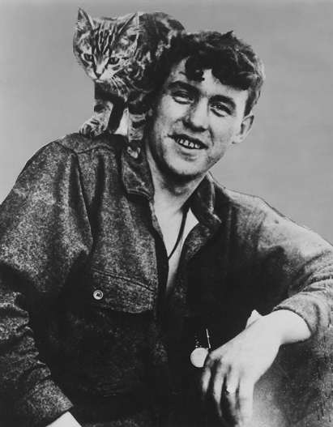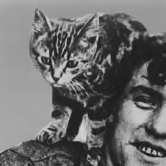

**2: Take-off**

<http://www.airshipsonline.com/airships/r34/index.html>

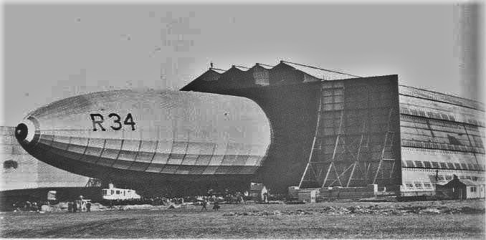

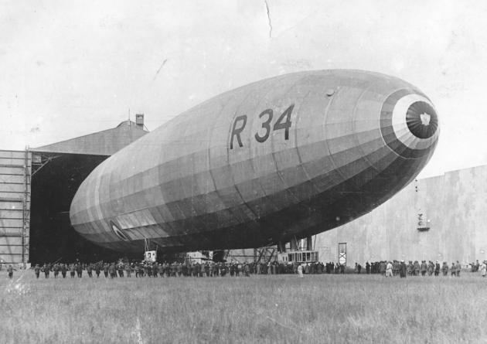<https://www.edp24.co.uk/news/centenary-of-r34-airship-record-breaking-flight-marked-norfolk-1-5608608>

**3: Gondola**

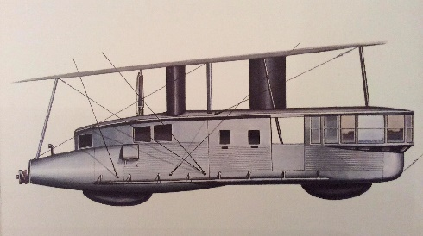<http://www.airshipsonline.com/airships/r34/index.html>

**4: Crew**

Provided by client (Diss Museum)

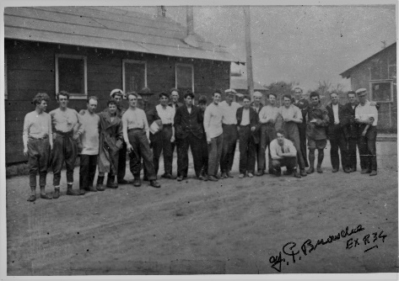

<http://www.airshipsonline.com/airships/r34/index.html>

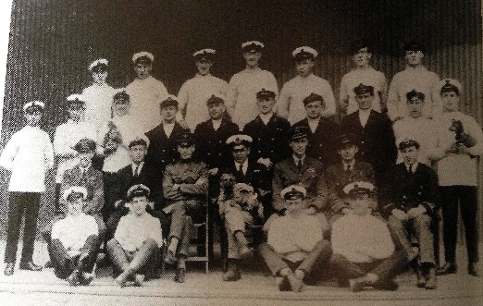

**5: Stowaway (William Ballantyne)**

<https://blog.nms.ac.uk/app/uploads/2016/05/Ballantyne-and-Wopsie-700px.jpg>



**6: Weather**

<http://www.airshipsonline.com/airships/r34/index.html>

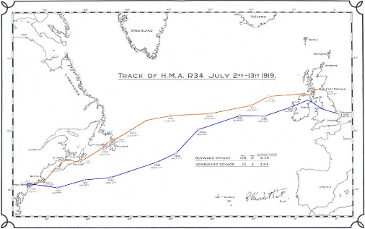

**7: Major Pritchard**

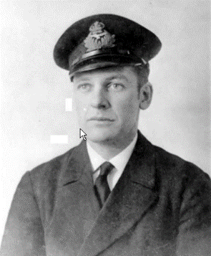(provided by client, Diss Museum)

**8: NY Landing**

<https://www.youtube.com/watch?time_continue=42&v=lvp8XqNmHps>

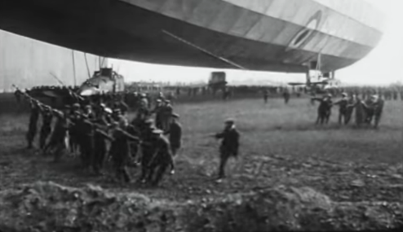

<https://www.polartrec.com/expeditions/icecube-in-ice-antarctic-telescope-2012/journals/2012-06-03>

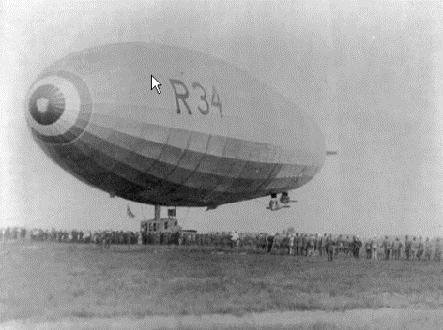

**9: Homecoming**

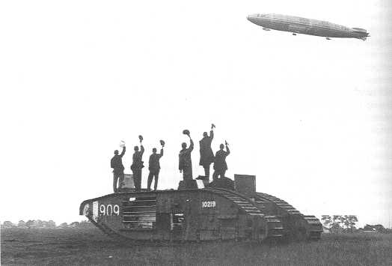<http://www.airshipsonline.com/airships/r34/index.html>